**[It’s Time: Why You Need to Upgrade to an SSD Right Now](http://www.howtogeek.com/194750/its-time-why-you-need-to-upgrade-to-an-ssd-right-now/" \o "It’s Time: Why You Need to Upgrade to an SSD Right Now)**

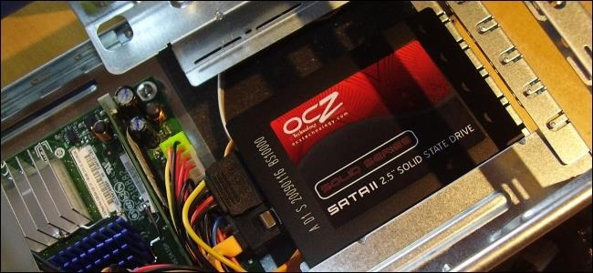

It’s time to upgrade to an SSD if you’re still using a mechanical hard drive in your computer. An SSD is the single biggest upgrade you can give your computer, and prices have come down dramatically.

[Solid-state drives](http://www.howtogeek.com/howto/45359/htg-explains-whats-a-solid-state-drive-and-what-do-i-need-to-know/) are so much faster because they don’t have a spinning magnetic platter and moving head. After upgrading, you’ll be amazed at the performance improvements and wondering why you waited so long.

The short version: SSDs are cheap, you can get [256 GB for $112](http://buy.geni.us/Proxy.ashx?TSID=9350&GR_URL=http%3A%2F%2Fwww.amazon.com%2Fdp%2FB00KFAGCWK%2F%3Ftag%3Dhotoge-20), or a [512 GB for $212](http://buy.geni.us/Proxy.ashx?TSID=9350&GR_URL=http%3A%2F%2Fwww.amazon.com%2Fdp%2FB00KFAGCUM%2F%3Ftag%3Dhotoge-20), or even a [1 TB for only $360](http://buy.geni.us/Proxy.ashx?TSID=9350&GR_URL=http%3A%2F%2Fwww.amazon.com%2Fdp%2FB00OBRFFAS%2F%3Ftag%3Dhotoge-20). Nothing else will give you the speed increase that a new SSD will.

Why SSDs Blow Mechanical Disks Out of the Water

We used CrystalDiskMark to benchmark a recent, inexpensive solid-state drive and a 7200 RPM hard disk drive. Here are the results, with the SSD on the top and the older mechanical drive on the bottom.

The results speak for themselves. Even with sequential writes reads and writes, the SSD was more than twice as fast. When it came to one particular type of random reads and writes — reads and writes to random locations all over the disk — the SSD was more than 400 times as fast. With a mechanical hard drive, the physical heads need to move around to read data from a spinning magnetic disk. With a solid-state drive, the drive can read or write data from any location on the disk with no performance penalty.

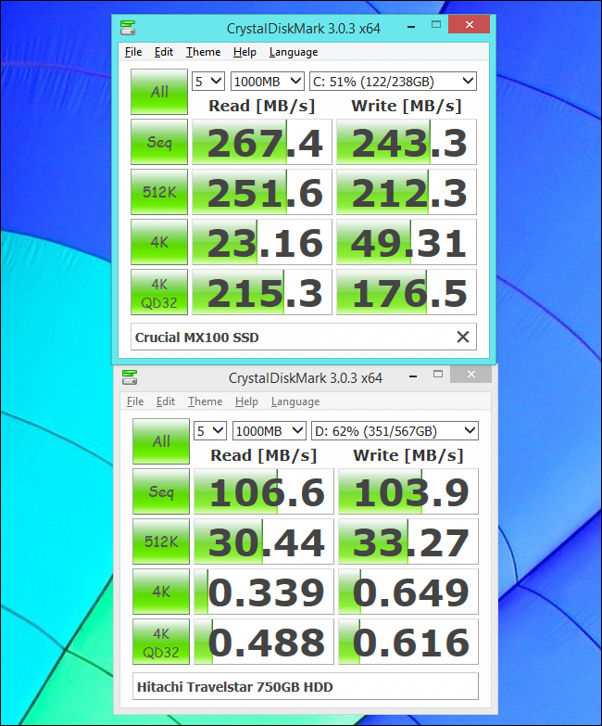

It’s not just theoretical benchmarks that improve. Your computer becomes much, much faster to boot. How much of an improvement depends on your operating system, hardware, and what software is loading at boot — but you can make it down to 10-20 seconds, even on an older Windows 7 system. Your desktop will load much more quickly after you log in too. Even if you have a lot of [nasty bloatware running at boot](http://www.howtogeek.com/174587/refreshing-your-pc-wont-help-why-bloatware-is-still-a-problem-on-windows-8/), your desktop will become usable much more quickly.

Launching a program, opening a file, and saving something to disk will all happen much, much faster. Click a program, and it can load almost instantly. All those little moments of waiting you don’t notice when you use your computer are adding up. Even just browsing the web will be faster — with your browser’s cache files stored on an SSD, they’ll load almost instantly instead of more slowly from a mechanical drive.

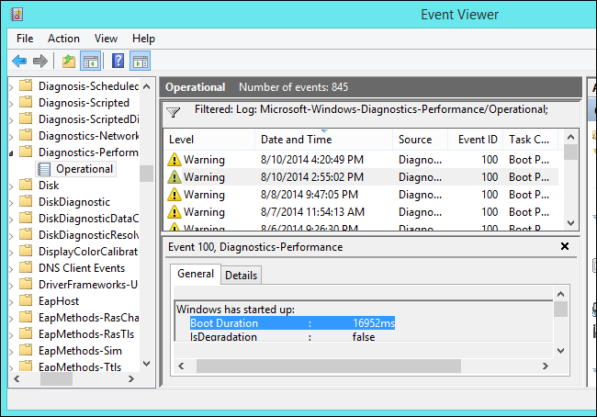

Large SSDs Are Now Inexpensive

SSDs used to be very expensive, especially for the small amount of storage space they had. In 2008, an 80 GB Intel SSD would cost you $595. That’s a whopping $7.43 per GB.

You can now get a sizable [Crucial MX100 256 GB SSD](http://buy.geni.us/Proxy.ashx?TSID=9350&GR_URL=http%3A%2F%2Fwww.amazon.com%2Fdp%2FB00KFAGCWK%2F%3Ftag%3Dhotoge-20) for about $112. That’s only $0.43 per GB. Need less space? [128 GB will only cost you $74](http://buy.geni.us/Proxy.ashx?TSID=9350&GR_URL=http%3A%2F%2Fwww.amazon.com%2Fdp%2FB00KFAGD88%2F%3Ftag%3Dhotoge-20) — about $0.58 per GB. If you need more, [you can get 512 GB for $212](http://buy.geni.us/Proxy.ashx?TSID=9350&GR_URL=http%3A%2F%2Fwww.amazon.com%2Fdp%2FB00KFAGCUM%2F%3Ftag%3Dhotoge-20) — more expensive, but still a pretty good deal at $0.41 per GB. And if you want serious drive space, [you can get a 1TB SSD for only $360](http://buy.geni.us/Proxy.ashx?TSID=9350&GR_URL=http%3A%2F%2Fwww.amazon.com%2Fdp%2FB00OBRFFAS%2F%3Ftag%3Dhotoge-20), which is still a pretty good deal compared to the manufacturer upgrades for most laptops.

These aren’t even low-quality drives — they have glowing reviews. Wait for a sale on these drives and you might end up spending even less! You don’t have to get these specific drives, but they are a great example of where prices are headed.

This can seem awfully expensive when you can get a 2 TB mechanical hard drive for $113 or so. That’s only about $0.06 per GB! But how much space do you really need? For nearly every computer user, speed is more important than raw capacity. You’ll feel speed all the time, but most people won’t need to store 2 TB of data on their drives. If you do need the space, that’s a great reason to get both — an SSD for your system files and programs, and a mechanical drive for long-term storage of media files and other stuff you don’t need the speed for.

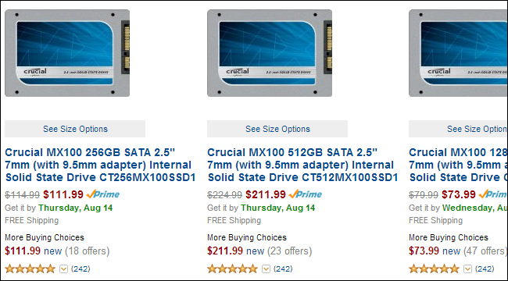

Installing an SSD is Easy

Installing an SSD is pretty simple — it’s basically the same as [installing a hard disk](http://www.howtogeek.com/74061/hardware-upgrade-how-to-install-a-new-hard-drive-pt-1/). Assuming you’re using a desktop PC, you can easily power down your computer, open its case, and insert the SSD drive into a drive bay. You should have more than one drive bay, so you can install the SSD alongside your mechanical drive and keep using the old mechanical drive for additional storage space.

[Upgrading a laptop may be a bit more complicated](http://www.howtogeek.com/192016/what-you-need-to-know-about-upgrading-your-laptops-hardware/), but it’s often still not too difficult. Assuming you an open up your laptop, you can swap an SSD for the included drive. You can also get optical-drive-bay-to-SSD kits that will allow you to swap out your DVD or CD drive for an SSD.



Once your SSD is installed, you can easily reinstall [Windows on your computer](http://www.howtogeek.com/133254/beginner-geek-how-to-reinstall-windows-on-your-computer/) and restore your important files from a backup for a nice, clean, fresh, speedy system. That’s what we recommend.

If you really want to keep your old Windows install, you can. Many solid-state drives come with free drive-cloning software that will help you migrate the contents of your old drive straight to your SSD. Manufacturers want to make it as easy to upgrade as possible. If you need to do this on your own and the drive doesn’t come with any imaging software, we have a guide that will help you [migrate your existing Windows install to an SSD](http://www.howtogeek.com/97242/how-to-migrate-windows-7-to-a-solid-state-drive/).

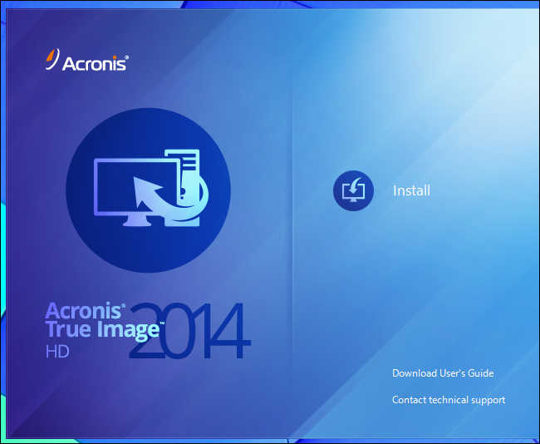

Sure, maybe you can’t upgrade to an SSD. Perhaps you have a laptop that you just can’t open, or perhaps you need the money for other things right now. Even so, an SSD upgrade is the single best upgrade you can give your PC, and it can keep that PC running nice and fast for years to come. If you spend a lot of time at the computer, you’ll see a huge quality-of-life improvement. They’re now available at great prices for a good amount of storage, so the price premium they command over mechanical drives is much less important. You can always have a separate mechanical drive for more storage too.